Easton C E Academy

Mathematics Policy and Procedure

Introduction
At Easton C E Academy, we believe that developing mathematical knowledge and concepts equips children with important life-skills and helps them to make sense of the world around them. Mathematics is a means of analyzing and communicating information and ideas; it is a tool for problem solving and encourages logical thinking and reasoning. Mathematics is one way of teaching flexibility, initiative, accuracy, systematic logical thinking and is a source of interest and fun.

It is our aim to develop:
A ‘mastering’ approach to mathematics
A positive attitude towards mathematics with a growth mind set about abilities
A secure understanding of numbers, their place value and wider mathematical concepts and skills
Accurate and precise use of mathematical knowledge
Mathematicians who can problem solve and reason using their arithmetic skills, work systematically and use their prior knowledge to make links

Our focus for 2023-2024
At Easton C E Academy, our aim is to continue using the Mathematics Mastery Approach to teaching Mathematics whilst using the White Rose Maths Hub schemes of work and planning resources.

Children will receive high quality maths lessons, which have been carefully differentiated, ensuring that all children have access to learning.

Mathematical teaching will encourage problem solving, where children will use their mathematical knowledge and vocabulary to justify their reasoning. This approach encourages a deeper understanding of concepts.

Teaching and Learning
Children should become confident learners of mathematics in a supportive and safe environment. A consistent approach to maths teaching across all year groups offers our children a secure framework in which to take risks.

At Easton C E Academy, planning is based on the Mathematics Mastery approach which focuses on deepening understanding by utilising a concrete, pictorial, abstract approach. As a school, we use the White Rose Maths schemes of learning to support the planning of our maths curriculum, as well as the NCETM for further fluency and problem solving.

WRM - https://whiterosemaths.com
NCETM - https://www.ncetm.org.uk/classroom-resources/assessment-materials-primary

Teachers’ planning and organisation
All teachers plan daily mathematics lesson using the agreed planning format, where certain time is spent on specific units ensuring that all areas of the National Curriculum are covered. A long term plan is used to map out the key objectives for each year group.

A medium term plan maps out the learning for each term (closely matching the long term plan), highlighting the key learning objective and when unit assessments will be carried out. These are adapted according to the childrens’ needs and responses during their Cold Tasks.

Planning is done on a weekly basis which includes:
- A written overview of the week with specific learning objectives for each lesson
- Weekly SMART/ PowerPoint slides with
- Starters (5 a day, Flashback 5 or times table/number fact – work on gaps) – 5/10 minutes
- Main input of the lesson 30 -40 minutes, breaking down the learning objective into smaller steps with scaffolding (I do- We do – You do). Go through the success criteria, key vocabulary and use sentence stems. Ensure there are opportunities for reasoning and problem solving
- Effective plenaries – 10 minutes (addressing misconceptions/ summarising key learning)
- Providing children with ‘Fix it’ time, where children can correct any errors
- One ‘Number Talk’ session per week (KS2) which is a mental maths session focusing on pupils’ mathematical reasoning
- Year 1 – 4 will have ‘Maths Challenges’ which focus on their mental math skills. This will happen once a week, during a Maths lesson, rather than a ‘5 a day/ Flashback 5’. Year 5 and 6 will complete the ‘Eleven Club’ challenges for their mental math challenge once a week.
- Year 4 will also have one extra session out of the Maths lesson on their multiplication facts.
- Mastering Number sessions (EYFS and KS1)
- KS2 – Securing skills should be done out of the maths lesson as early work or after lunch

During each unit, children should be exposed to a range of experiences. For example, having practical activities, using mathematical games, group problem solving activities, paired work, class discussions, open and closed tasks. These opportunities should encourage children to use a variety of methods to calculate, use their known facts to solve unknown facts, seeing which method is the most efficient.

A ‘Calculation Policy’ is written separately to ensure consistent and continual use of number skills. (Please check the Maths Folder in Easton Curriculum)

Differentiation
Differentiation is achieved by emphasising deep knowledge and through individual support and intervention. Practice and consolidation play a central role.

Teachers differentiate in various ways
- Use precise questioning in class to test conceptual and procedural knowledge, and assess pupils regularly to identify those requiring intervention
- Provide scaffolded learning steps which supports and challenges all
- Responses – some children may write/ draw/ give verbal feedback (use photos to evidence their learning)
- Grouping according to ability when appropriate. Some work may involve targeted group work when working independently. (NOTE- this should be flexible and according to the needs of the children).
- Math tasks to build on one another and develop secure skills. Mathematical tasks are labelled as challenges and the number gives a hierarchical indication of the level with Challenge 1 being simplified or more heavily scaffolded (based on fluency) and Challenge 2 getting increasingly more complex (this could be moving to reasoning and problem solving).
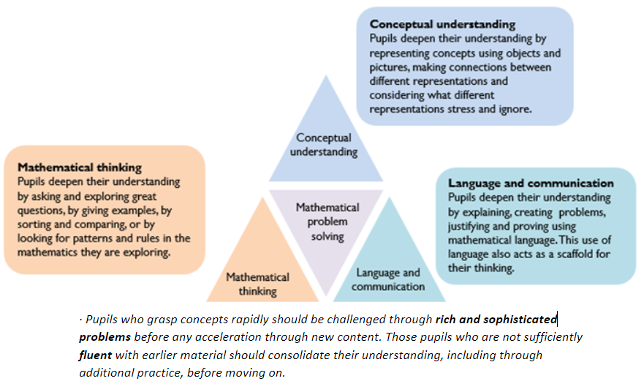

Some simple differentiation ideas
- Detective – finding errors – Mathematical thinking
- Draw a picture of… Conceptual understanding
- ‘Prove it’ using a new manipulative Conceptual understanding
- Think of stories to tell about the numbers, shapes, patterns etc. Language
- ‘Explain to your partner’ Language
- ‘Show me’ using a concrete manipulative Conceptual understanding
- Simpler/fewer instructions or steps – reducing/increasing scaffolding

For children who are far behind it is advised that they are assessed using other year groups assessments to establish an accurate baseline. It is also important that they are given opportunities to work independently so they do not become too reliant on adult help.

Marking
In line with the marking policy- see appendix 1
- Highlighting the WALT in green (secure) or pink (not secure)
- Green tick for the correct answer and a pink dot for the incorrect answer
- Write VF (Verbal feedback) or WS (with support) where applicable
- Response Task once a week

Working Wall
Each class is to have a Maths Learning Wall with
- Squared backing paper with examples of current work
- ‘Steps to Success’ linked to the learning objective
- Key Vocabulary of the unit
- ‘Today’ and ‘Yesterday’ learning examples
Year 1 can have general learning objectives of the unit that is being taught as of when it is needed.

Assessment
At the end of EYFS, children are assessed on the maths objectives for the curriculum. These areas include: subitising numbers; repeating patterns; investigating more than and fewer than; linking number names and values; composition of 10; comparing numbers; number bonds; investigating the language of shape; exploring positional language and measures.
Make ongoing assessments and respond appropriately to pupils during daily teaching
At the end of KS1, children are assessed in arithmetic and reasoning skills through teacher assessment and tests.
At the end of KS2, children are assessed on the end of key stage tests (SATs). There are 3 tests: arithmetic and two reasoning papers. Teacher assessment is also completed for maths at the end of KS2.
Currently, other year groups (Y3, Y4 and Y5) complete the NFER tests end of term 2,4 and 6 tests and regular arithmetic skills tests to assess progress and attainment. Year 1 have teacher assessments (some practical assessments).
Hot and Cold Tasks – Based on the WRM small steps, question children on the key learning points of that unit. Ensure that this is differentiated according to the needs of the children. Use templates provided (blue = cold and red = hot). Track the results on a sheet at the front of their Mathematics Assessment Folder and keep these separate to the daily maths work.

Vocabulary

All lessons should have key vocabulary listed on the working wall. Children should be encouraged to use the key words in their mathematical dialogues and use full sentences. There should be call and response when learning new words. Sentence stems should be provided to support the children when they are reasoning.

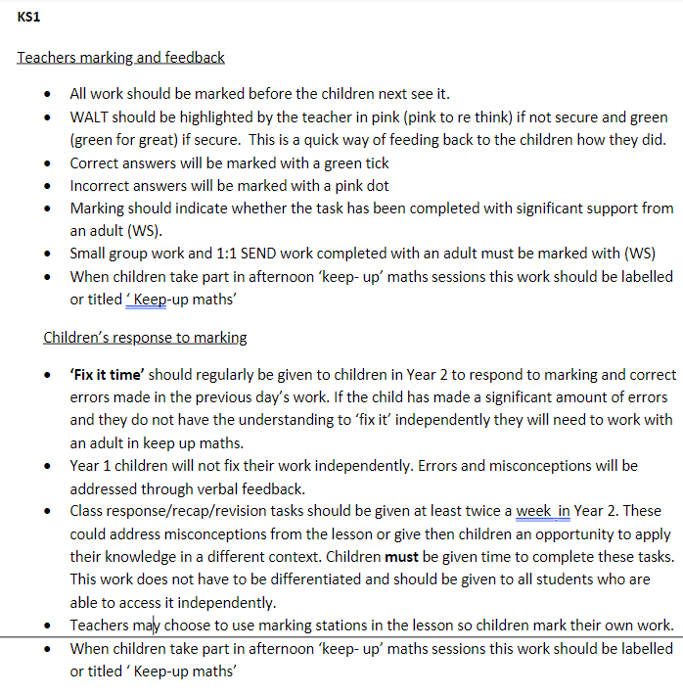
Appendix 1- Marking policy

