**Easton CE Academy**

**Handwriting intent and implementation**

At Easton CE Academy we believe that handwriting is a skill which, like reading and spelling, impacts on work across the curriculum. We believe that neat, well formed handwriting and presentation of written work helps to raise standards as the pupils take pride in and have a sense of ownership of their work. The school teaches precursive letter formation initially, with some joining taught in Y2 during the summer term and a fully joined cursive style taught from Y3.

**Intent:**

* Children will achieve a neat, legible style with correctly formed letters in cursive handwriting.
* Children will develop flow and speed, so that eventually they are able to produce the letters automatically in their independent writing.
* We will have a consistent approach across EYFS, KS1 and KS2 when teaching handwriting and presentation of work throughout the school.

**Implementation:**

Handwriting is taught regularly within daily Sounds Write Lessons and also in stand-alone lessons.

* In EYFS and KS1 letter formation will be taught as children are introduced to the letters in Sounds Write lessons and practised at other times in the day.
* In Year 3 and 4 Handwriting will be taught at least three times a week all year.
* In Year 5 and 6 Handwriting will be taught at least three times a week until the vast majority of children have established a fluent joined style at age-related standard. Further support must be provided for individuals or small groups where needed.
* In addition, shared and guided writing provide opportunities for the modelling and monitoring of handwriting.
* Individual teaching and time to practise is provided for children who are experiencing difficulties in meeting expectations at any point across the school.

**Foundation Stage**

The emphasis at this stage is with movement rather than neatness. Letter formation (starting at the right entry point and then moving in the right direction) learned at this early stage becomes automatic and has a profound influence on later fluency and legibility. Pupils are taught precursive letter formation. Close attention is given to pencil grip, correct posture, the positioning of the paper and the organisation of the writing space.

**Key Stage 1**

In Y1, children continue to focus on individual letter formation. In Y2 there is a continued focus on individual letter formation and some joins are taught in the summer term. By the end of year 2 children should have a fluent legible style with at least some joins.

**Key Stage 2**

The target for children in KS2 is to produce a fluent, consistently formed style of fully joined handwriting with equal spacing between the letters and words.

**Left-handed pupils**

All teachers are aware of the specific needs of left-handed pupils and make appropriate provision.

**Correct pencil grip:**

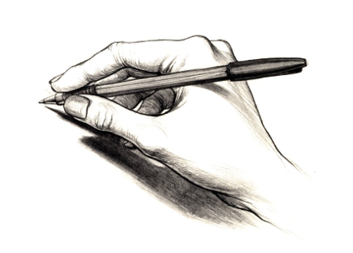

**Letter formation:**

