Hello to all our families, 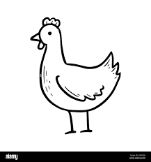
We have had a great start to term, with lots happening already. Nursery have been to Noah’s Ark Zoo Farm and Year 5 have been to camp on a farm on Dartmoor. There are many more trips coming up and everyone is enjoying being able to play on the field in the sunshine. We are all working hard too!
SATs week: Year 6 will be doing their SATs tests from 13th- 16th May. Please make sure children are in promptly and get to bed early each night. The kitchen are doing a special breakfast for Year 6 children on those days, starting at 8.15am.
Dates for next year in school
- Term 1: Wednesday 4th September 2024 to 25 October 2024
- Term 2: 4 November 2024 to 20 December 2024
Please make sure all your holidays are in a school holiday. Every day at school is important for your child’s learning and their wellbeing. It is particularly important that all children start back on the 4th September.
Our value of the term this term is friendship. Please help children to be friendly when texting as well as in person. We are encouraging children to use good manners and make our school a friendly place by saying ‘please’ and ‘thank you’.
Have a look at these special events: 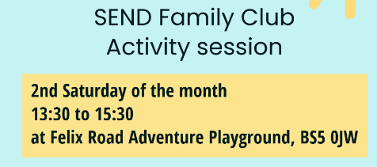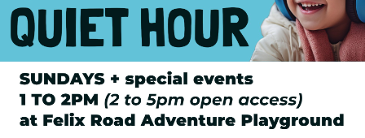
There are free online parenting courses available for every parent:
https://www.bristol.gov.uk/bristol-family-hubs/parenting-courses

Please remember that children need to wear uniform every day. This helps children to feel like they belong and are a part of our school. If children arrive wearing something else they will be given a clean uniform jumper to put on.
Any questions? Ask one of the leadership team in the playground.

From Mrs Welbourne

