
Hello to all our families,
We are so delighted to see you all back this term and to welcome new children to Nursery and Reception and also to welcome some new families. Children have come to us from nearby and from a variety of countries and we know that you will welcome them and help them as they start at our school.
Some new staff have joined us this term and we are very grateful for their hard work already
Miss Mohamad - Y3 teacher
Miss Smart – learning mentor (Our learning mentors help children with behaviour)
Miss George – HLTA in Year 1 (HLTAs are senior teaching assistants who can cover for teachers)
Mrs Suzie Gibson – job sharing with Toria Moore. Suzie is working on Tuesdays and Wednesdays and is available to help families just like Mrs Moore
Miss Richards – TA in year 4, Miss Cheema and Miss Lee – TA sin Reception

Almost all children are wearing their uniform, which is great.
They should wear a school jumper every day, with a white polo shirt and black or grey trousers or skirt. On PE days they can wear tracksuit bottoms or leggings. PLEASE write your child’s name in jumpers – we ended last year with a mountain of unnamed clothes!
We hope most children will have a school dinner. Do ask in class if you would like a menu.
If you are choosing to provide a packed lunch please give your child:
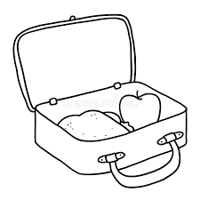
A sandwich, wrap,rice or noodles
Some fruit or vegetables
Yogurt
A treat, like crisps, cake or biscuits
A drink – water is best
Please do not include sweets or fizzy drinks and NO NUTS OR NUTELLA (We have children who a allergic to nuts.
There is lots on in school, with children already hard at work in reading, writing and maths. Music lessons are starting again and the older children are having a weekly arts lesson as well. Check the website to see all the things your child will learn this year.
If you have any questions about school please ask your child’s teacher or find one of the leadership team in the playground. If you still have worries, ask in the office to make an appointment to see one of the team. We are here to help you and your child!

